**Supporting Information**

For

**Exciton Diffusion and FRET in Dye-doped Conjugated Polymer Nanoparticles**

Louis C. Groff, Xiaoli Wang, and Jason D. McNeill

1. **Preparation and Characterization of Conjugated Polymer Nanoparticles (CPNs)**

The copolymer poly[(9,9-dioctylfluorenyl-2,7-diyl)-*co*-(1,4-benzo-{2,1',3}-thiadiazole)] (PFBT, MW 10,000, polydispersity 1.7) was purchased from ADS Dyes, Inc. (Quebec, Canada). The fluorescent dye perylene red (Exalite 613) was purchased from Exciton (Dayton, OH). The fluorescent dye fluorescein was purchased from Invitrogen (Eugene, OR). The solvent tetrahydrofuran (THF, anhydrous, 99.9%) and sodium hydroxide (SigmaUltra, minimum 98%) were purchased from Sigma-Aldrich (Milwaukee, WI). All chemicals were used without further purification. Preparation of the fluorescent nanoparticles was performed using a previously described reprecipitation method.1 The copolymer PFBT was dissolved in THF by gentle agitation and prepared at a concentration of 1000 ppm. Perylene red was dissolved in THF by gentle agitation and prepared at a concentration of 100 ppm. The solution was further diluted to 2 ppm for doping. Varying amounts of the dopant perylene red solution were mixed with the PFBT solution to produce solution mixtures with a constant concentration of 20 ppm PFBT and dopant/host fractions of 0 to 2 wt% perylene red. The mixtures were sonicated very briefly to ensure homogeneity. A 2 mL quantity of each solution mixture was added rapidly to 8 mL of deionized water under sonication. THF was removed from the resulting nanoparticle suspensions by partial vacuum evaporation and subsequently vacuum filtered through a glass fibre prefilter to remove larger aggregates and a 0.1 µm PTFE membrane filter. The resulting nanoparticle suspensions are clear (not turbid) and stable for months with no visible signs of aggregation.

Size distributions and morphologies of undoped and perylene red doped PFBT nanoparticles were determined by atomic force microscopy (AFM). Samples were prepared by functionalizing the surface of a freshly cleaned glass coverslip with 3-aminopropyl-trimethoxysilane in anhydrous ethanol, followed by dipcasting in a diluted nanoparticle suspension for 40 minutes, then removing the coverslip and allowing it to dry overnight in an enclosed environment. Surface topographies were measured on an Ambios Q250 multimode AFM in tapping mode. As shown in Figure 1 in the main text, the mean diameter of the CPNs was 8 ± 2 nm. All of the perylene red doped PFBT CPN samples showed no substantial changes in mean diameter, with a similar size distribution.

UV-Vis absorption spectra were collected on a Shimadzu UV2101PC scanning spectrophotometer using 1 cm quartz cuvettes. Fluorescence spectra were collected and fluorescence quantum yield was measured using a commercial fluorimeter (Quantamaster, Photon Technology International, Inc.) using 1 cm quartz cuvettes. The UV-Vis spectra showed no variations from the undoped spectrum over the range of doping, and the absorbance of perylene red was well below the limit of detection of the instrument in the CPN suspensions. The fluorescence spectra of the CPN samples are given in Figure 2 in the main text.

1. **Fluorescence Quantum Yield**

The standard fluorescent dye fluorescein in 0.01 M sodium hydroxide was utilized to determine the fluorescence quantum yield of the PFBT CPN samples. 473 nm was selected as the excitation wavelength. The concentrations of the standard and nanoparticle suspensions were adjusted to yield an absorbance of ~0.05 at 473 nm. The absorbance, integrated fluorescence, and refractive indices of the sample and standard solutions were used in conjunction with the literature value of 0.92 for the quantum yield of fluorescein in 0.01 M sodium hydroxide to calculate the fluorescence quantum yield of the nanoparticle suspensions.2 The results of the quantum yield measurements are given in Figure 2 in the main text.

The change in quantum yield upon removing oxygen from the undoped PFBT CPN samples was also measured. Samples were purged with nitrogen in the dark for 45 minutes prior to measurement. The quantum yield in air was measured to be 0.097, and 0.100 in nitrogen. The differences in quantum yield for the sample in air compared to the data in Figure 2 is owed to batch-to-batch variability in the CPNs. Nevertheless, the quantum yield results indicate that the brightness of the CPNs is insensitive to oxygen removal.

1. **Picosecond Time-Correlated Single Photon Counting (TCSPC) Spectroscopy**

Fluorescence lifetimes were measured in air using time-correlated single photon counting (TCSPC) spectroscopy. The second harmonic (420 nm) of the output of a mode-locked Ti:Sapphire laser (Coherent Mira 9000, ~100 fs pulses) was used to excite the samples. The output of a fast PIN diode (Thorlabs DET210) monitoring the pulse shape was used as the start pulse for a time-to-amplitude converter (TAC, Canberra Model 2145). The laser output incident on the PIN diode was attenuated until the output voltage of the PIN diode read 200 mV. Nanoparticle fluorescence was collected perpendicular to the excitation source after passing through a 460 nm long pass filter for the undoped nanoparticles. An additional 540 ±10 nm band pass filter was added for the doped samples in order to filter out the emission from perylene red. For the measurement of acceptor lifetimes, a 600 nm long pass filter was added in place of the 540 ± 10 nm band pass filter to remove the emission from PFBT. The emission was detected by a single photon avalanche photodiode (APD, Perkin-Elmer, SPCM-AQR). The output of the APD was used as the stop pulse for the TAC. The excitation pulse was attenuated to maintain a count rate ~6 kHz. The analog signal from the TAC was digitized using a multichannel analyzer (FastComTec, MCA-3A). Before and after each fluorescence lifetime measurement, the instrument response function (IRF) was measured using scattered laser light from a dilute suspension of polystyrene microspheres. The width of the resulting IRF was ~80 ps (FWHM).

The effect of removing oxygen from the nanoparticle samples on the lifetime was also assessed by purging the undoped PFBT CPN samples with nitrogen. The bi-exponential weighted average lifetimes of the undoped PFBT CPNs were measured to be 780 ps in air and 850 ps in nitrogen. Again, the differences from the results in text are due to batch-to-batch variability in the CPN samples. Regardless, this shows that the lifetime is relatively insensitive to oxygen removal.

In addition to the lifetimes of the host polymer PFBT, the lifetimes of the acceptor perylene red were measured. The lifetime of perylene red in THF was measured to be 5.4 ns, which is consistent with the literature.3 The moderate to heavily doped samples of PFBT nanoparticles were selected due to the relatively low contribution to the emission signal by PFBT as well as to assess the effect of the observed self-quenching of perylene red on its lifetime in the nanoparticles. The lifetime of perylene red doped within the nanoparticles was found to be reduced to 3.1 ns, and follows a decreasing trend as doping increases. The reduction in lifetime indicates that perylene red is dynamically self-quenched.

|  |  |
| --- | --- |
| **Perylene Red %(w/w)** | **τexp (ns)** |
| **THF** | 5.4 |
| **1.0%** | 3.1 |
| **1.5%** | 2.9 |
| **2.0%** | 2.6 |

1. **Exciton Diffusion/Energy Transfer Model**

We previously developed a Monte Carlo approach to modeling the combined effects of exciton diffusion and energy transfer in CPNs, which yielded values for energy transfer efficiency that were in agreement with experimental results for dye-doped CPNs.4 This approach was also applied to modeling fluctuations in the fluorescence centroid of a single CPN.5 Here, we have modified the previous simulation code to provide kinetics information for comparison to the time-resolved fluorescence results. We have also modified our approach to explicitly account for quenching by defects. The details of the simulation algorithm relating to nanoparticle simulation and distribution of dyes and defects are described in the main text. The energy transfer rate, for each exciton to each dopant or defect is calculated based on the exciton-acceptor distances and the conventional Förster rate expression. Based on the rates of energy transfer, radiative decay, and non-radiative decay, given by

, (S.1)

the probability of decay or transfer for a given exciton during the time step is calculated by

 (S.2)

and compared to a random number to determine the exciton fate. The exciton population is updated accordingly, and recorded for each time step. The simulation continues until nearly all of the exciton population has decayed. The simulations are performed for many initial random configurations of acceptors and excitons, and the exciton population kinetics and energy transfer efficiencies are calculated from the simulation results.

The inclusion of quenching by defects is discussed in the main text and given in greater detail here. The observations motivating the addition of quenching by defects are given as follows. First, the fluorescence quantum yield (c.f. Fig. S1) and excited state lifetime of the nanoparticles is greatly reduced ( = 0.14,  = 800 ps) as compared to the polymer in a good solvent such as THF ( = 0.66,  = 3000 ps). Lifetime reductions and large increases in radiative rate due to strong transition dipole coupling are typically observed in J-aggregates.6 However, strong J-aggregate-type coupling is not likely in the present case, since little shift in the absorption spectrum is observed upon nanoparticle formation (c.f. Fig. S1). Furthermore, the radiative rate, estimated from the lifetime and quantum yield values, is actually somewhat lower in the nanoparticles (1.8x108 s-1), as compared to the polymer in THF (2.2x108 s-1), which does not correspond to typical J-aggregate behavior. Finally, the heterogeneity of the excited state lifetime of the nanoparticle is increased (*ß* = 0.65) as compared to the free polymer in solution (*ß* = 1.0), consistent with quenching by energy transfer to defects or other quenching species. Further support for the defect-quenching hypothesis is given in the results of exciton diffusion-energy transfer simulations, discussed in the main text.

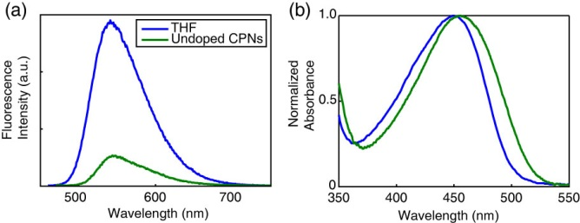

**Fig. S1.** (a) Fluorescence spectra and (b) normalized absorbance spectra of PFBT in THF (blue) and undoped PFBT CPNs (green).

The defect density per nanoparticle (expressed in dye equivalents) has been added as a model parameter in order to account for quenching by defects in CPNs. This was accomplished by explicity accounting for the Poisson distribution of defects and dyes in the model. The implementation of the Poisson distribution of defects and dyes is given in the main text. It is assumed that a combination of exciton diffusion and energy transfer in the aggregated state of the polymer are the principal causes of defect quenching in the nanoparticles. The single exponential decay kinetics and high quantum yield exhibited by the polymer in good solvent, assumed to be due to the open conformation of the polymer, as well as the reduction in quantum yield and complex decay kinetics exhibited in the aggregated state of the polymer supports this notion. In order to quantify the defect density per nanoparticle, the quantum yields of PFBT in THF and undoped CPNs were utilized to first estimate the defect quenching efficiency QEdef = 1-(ɸpoly/ɸCPN) which yields a quenching efficiency of ~0.79. Exciton diffusion and energy transfer simulations were performed using the same model parameters as were used to model the dye-doped CPNs, varying the defect density until good agreement with the quenching efficiency, lifetime and beta of undoped CPNs was obtained, yielding a defect density of 2.3 defects per nanoparticle or 8.6x1018 defects per cubic centimeter of polymer.

The exciton diffusion length was then obtained by performing simulations incorporating energy transfer to perylene red dyes, adding the defect density and dye densities for each weight fraction of dye and varying the exciton diffusion length to find the best match to experimental quenching efficiencies, lifetimes, and beta. This is given in detail in the main text. By introducing quenching by defects and Poisson statistics into the model, there is a trade-off in that the fit to experimental quenching efficiency is somewhat poorer, but the match to the lifetimes and particularly beta is greatly improved, compared to the simulations neglecting quenching by defects in the limit of large particles (c.f. Fig S2).

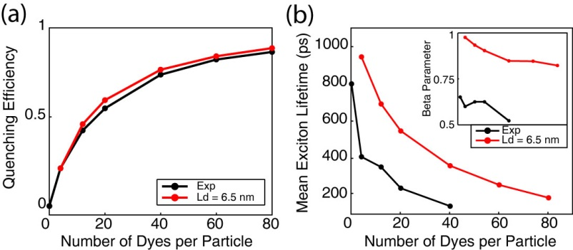

**SI Fig. 2.** Exciton diffusion simulation results ignoring quenching by defects and Poisson statistics. (a) Simulated (red) and experimental (black) quenching efficiency, (b) mean exciton lifetimes, and beta (inset) as a function of dyes per nanoparticle for a particle radius of 12 nm.

Results of exciton diffusion simulations (c.f.Fig S3) indicate that an increase in *either* *LD* or *R0* (or both) results in an increase in quenching efficiency. While there is no simple, exact analytical formula relating *LD* and *R0* to the *β* parameter, we found that *β* increases monotonically with increasing *LD*, (i.e., increasing *LD* results in a decrease in the amount of heterogeneity in energy transfer rates) while *β* decreases as *R0* increases. By including analysis of the *β* parameter, as well as quenching by defects, we obtained a significantly larger value for the Förster radius than that obtained using the typical assumption of *κ2* = 2/3, suggesting that this assumption should be reexamined.4

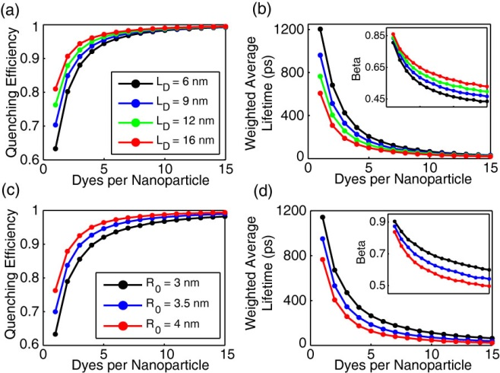

**Fig. S3.** Initial exciton diffusion simulations for a 4 nm particle radius. (a,b) Quenching efficiency, bi-exponential weighted average lifetime, and beta (inset) vs. dyes per nanoparticle for LD = 6 nm (black), 9 nm (blue), 12 nm (green), and 16 nm (red). (c,d) Quenching efficiency and bi-exponential weighted average lifetime, and beta (inset) vs. dyes per nanoparticle for R0 = 3 nm (black), 3.5 nm (blue), and 4 nm (red).

**References for Supporting Information**

(1) Szymanski, C., Wu, C. F., Hooper, J., Salazar, M. A., Perdomo, A., Dukes, A., and McNeill, J. *Journal of Physical Chemistry B* **2005**, *109*, 8543.

(2) Weber, G.; Teale, F. W. J. *Transactions of the Faraday Society* **1957**, *53*, 646.

(3) Al-Kaysi, R. O.; Ahn, T. S.; Muller, A. M.; Bardeen, C. J. *Phys Chem Chem Phys* **2006**, *8*, 3453.

(4) Wu, C. F., Zheng, Y. L., Szymanski, C., and McNeill, J. *Journal of Physical Chemistry C* **2008**, *112*, 1772.

(5) Yu, J., Wu, C. F., Tian, Z. and McNeill, J. *Nano Lett* **2012**, *12*, 1300.

(6) Kometani, N.; Nakajima, H.; Asami, K.; Yonezawa, Y.; Kajimoto, O. *Journal of Physical Chemistry B* **2000**, *104*, 9630.